MYSQL TRIGGERS
Practical Examples and Student Exercises using MySQL Workbench

What is a Trigger in MySQL?
A Trigger is a database object that automatically executes when a specified event occurs on a table.
Note: You don't call a trigger manually. MySQL automatically executes it when INSERT, UPDATE, or DELETE happens.

Why do we use Triggers?
Triggers are mainly used for:
- Auditing – record who/what was changed
- Validation – prevent invalid data
- Automatic calculations
- Maintaining related/summary data
- Logging INSERT, UPDATE and DELETE operations
- Enforcing business rules

Types of MySQL Triggers
MySQL triggers are classified based on when they execute and what event activates them.

Timing
- BEFORE
- AFTER

Events
- INSERT
- UPDATE
- DELETE

- First Trigger Example – AFTER INSERT
Create an employees table:
CREATE TABLE employees(
emp_id INT PRIMARY KEY,
emp_name VARCHAR(50),
dept_id INT,
salary DECIMAL(10,2)
);
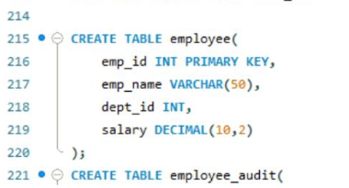
Create an audit table:
CREATE TABLE employee_audit(
audit_id INT AUTO_INCREMENT PRIMARY KEY,
emp_id INT,
emp_name VARCHAR(50),
action_type VARCHAR(20),
action_time TIMESTAMP DEFAULT CURRENT_TIMESTAMP
);
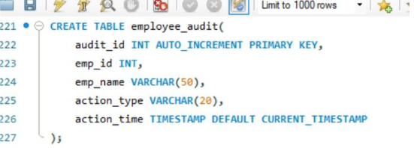
Now create the trigger:
DELIMITER $$
CREATE TRIGGER after_employee_insert
AFTER INSERT ON employees
FOR EACH ROW
BEGIN
INSERT INTO employee_audit
(emp_id, emp_name, action_type)
VALUES
(NEW.emp_id, NEW.emp_name, 'INSERT');
END $$
DELIMITER ;
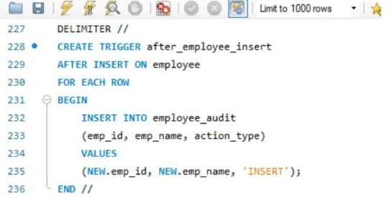
Now insert an employee:
INSERT INTO employees
VALUES (106, 'Arjun', 1, 52000);
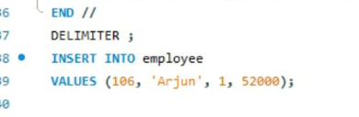
- You didn't call the trigger. It automatically executes.
SELECT * FROM employee_audit;
Output:
106 Arjun INSERT
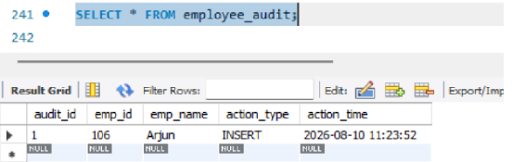
- Second Trigger Example – AFTER DELETE
Suppose Employee deleted:
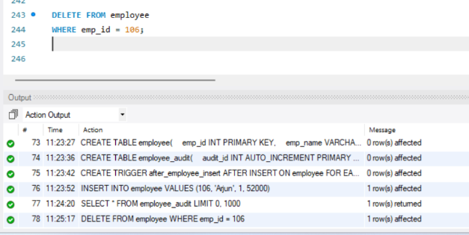
We can automatically record that deletion.
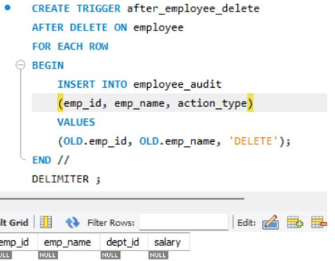
- Third Trigger Example--AFTER UPDATE Trigger:
UPDATE employees
SET salary = 60000
WHERE emp_id = 101;
We can record the update.
DELIMITER $$
CREATE TRIGGER after_employee_update
AFTER UPDATE ON employees
FOR EACH ROW
BEGIN
INSERT INTO employee_audit
(emp_id, emp_name, action_type)
VALUES
(NEW.emp_id, NEW.emp_name, 'UPDATE');
END $$
DELIMITER ;
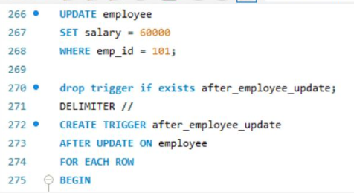
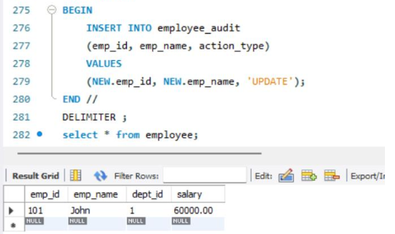

- Fourth Trigger Example--BEFORE INSERT Trigger:
Employee salary cannot be less than ₹20,000.
DELIMITER $$
CREATE TRIGGER check_salary
BEFORE INSERT ON employees
FOR EACH ROW
BEGIN
IF NEW.salary < 20000 THEN
SIGNAL SQLSTATE '45000'
SET MESSAGE_TEXT = 'Salary cannot be less than 20000';
END IF;
END $$
DELIMITER ;
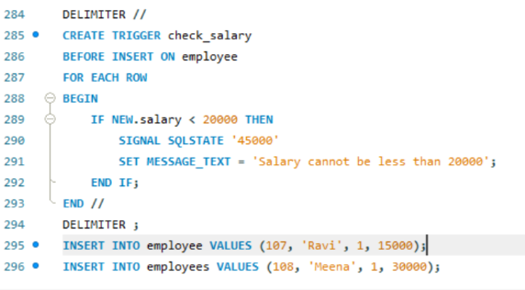

Now, run this Query
INSERT INTO employees
VALUES (107, 'Ravi', 1, 15000);
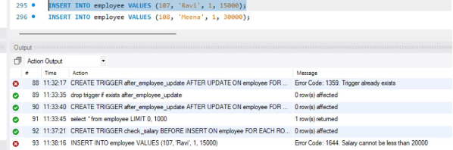

MySQL will reject it and display:
Salary cannot be less than 20000
But, If you run this Query it will succeed as salary is greater than 20000
INSERT INTO employees VALUES (108, 'Meena', 1, 30000);
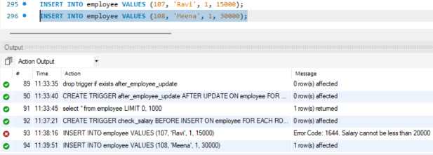

- Fifth Trigger Example--BEFORE UPDATE Trigger:
Suppose the company does not allow salary reduction.
DELIMITER $$
CREATE TRIGGER prevent_salary_reduction
BEFORE UPDATE ON employees
FOR EACH ROW
BEGIN
IF NEW.salary < OLD.salary THEN
SIGNAL SQLSTATE '45000'
SET MESSAGE_TEXT = 'Salary reduction is not allowed';
END IF;
END $$
DELIMITER ;
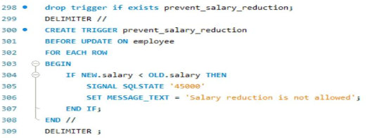
Now, run this Update Query
UPDATE employees
SET salary = 40000
WHERE emp_id = 101;
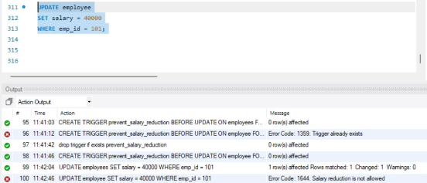
If the old salary was ₹50,000, the trigger rejects the update.
But, if you run the below update query, it succeeds as you are not reducing salary
UPDATE employees
SET salary = 60000
WHERE emp_id = 101;
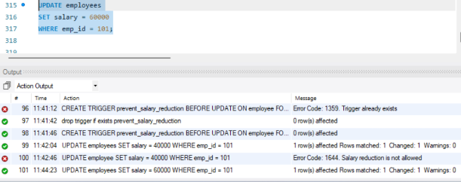
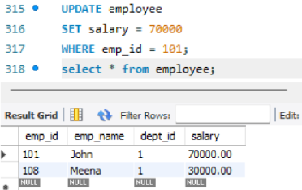
Here, after salary update
OLD.salary → 50000
NEW.salary → 60000

